Quantum Cryptography - A Technique
For Enhancement of Network Security

Shital V. Bahale
ME (CSE)
Prof. Ram Meghe Institute of Technology & Research, Badnera - Amravati.
shitalbahale@rediffmail.com

Abstract-
Securing data and data communication is a top priority because the consequences of insecure data can have grave effects on both the economy and national security. Cryptography is used to secure the information transmitted over telecommunication lines through appropriate encryption techniques. Quantum Cryptography provides more security level then any classical cryptosystem as quantum computing works according to the laws of quantum physics and does not depend on hard mathematical functions. Hence, the resulting Quantum Cryptosystem is more secure and cannot be cracked easily. The quantum cryptography relies on two important elements of quantum mechanics-the Heisenberg uncertainty principle and the principle of photon polarization. The Heisenberg uncertainty principle states that, it is not possible to measure the quantum state of any system without distributing that system. The principle of photon polarization states that, an eavesdropper cannot copy unknown qubits i.e. unknown quantum states, due to quantum no-cloning Theorem. This paper summarizes the current state of Quantum cryptography and exploration of quantum cryptography in Network Security.

Keywords: - Quantum Cryptography, QKD protocol, BB84 protocol, Key generation, Securing Key Distribution, Secured Quantum Cryptography Algorithm,

I-INTRODUCTION
The purpose of cryptography [1] is to transmit information in such a way that access to it is restricted entirely to the intended recipient, even if the transmission itself is received by others. The most advanced cryptography to date is quantum cryptography [7,15] because of breakthroughs in quantum computing. Current encryption algorithms based on mathematical model introduce potential security holes related to the key refresh rate and key expansion ratio. There are three main problems with encryption schemes [15].

The first is key distribution, the second is key management, where the number of keys required in a system with a large number of principals does not scale well. Thirdly as computing power increases, and new classical computational techniques are developed, the length of time
that a message can be considered secure will decrease, and
numerical keys will no longer be able to provide acceptable levels of secure communications. Quantum cryptography, or quantum key distribution (QKD) [8], uses quantum mechanics to guarantee secure communication. It enables two parties to produce a shared random bit string known only to them, which can be used as a key to encrypt and decrypt messages. The appealing characteristic of quantum cryptography is the possibility of distributing secret key [1] between two users in a manner that it is impossible for a third party to eavesdrop without changing the quantum transmission and hence the eavesdropping is detected by users. The quantum cryptography relies on two important elements of quantum mechanics-the Heisenberg uncertainty principle and the principle of photon polarization. According the Heisenberg Uncertainty principle, it is not possible to measure the quantum state of any system without disturbing that system.[3]. This principle plays a critical role in thwarting the attempts of eavesdroppers in a cryptosystem based on quantum cryptography. Secondly, the photon polarization principle describes how light photons can be oriented or polarized in specific directions. Moreover, a polarized photon can only be detected by a photon filter with the correct polarization or else the photon may be destroyed. It is Heisenberg’s uncertainty principle that makes quantum cryptography an attractive option for ensuring the privacy of data and defeating eavesdroppers.
In the past few years, a remarkable surge of interest from international scientific and business communities has propelled QC into mainstream computer science and physics. Furthermore, new developments are making QC increasingly practical.
This paper is organized as follow, section I is about introduction of topic, section II discusses QKD protocols, section III explores key generation problem and section IV discusses secure key distribution with SQCA algorithm. Thus paper explores quantum cryptography with quantum key distribution protocol. Paper also discusses eavesdropping and how quantum cryptography defends against it. Conclusion summarizes our proposed work.

II-QKD Protocols

There are three main security protocols for QKD: BB84, B92, and Entanglement-Based QKD. Author will only discuss BB84 in this section.
BB84 [4] was the first security protocol [11] implementing Quantum Key Distribution. The protocol suggested the use of quantum mechanics for two parties to agree on a joint secret key. The key consists of bits that will be transmitted as photons. Each bit is encoded with a random polarization basis. Working of BB84 protocol is as follows

1. Alice begins with a random sequence of bits encoded on a random basis, and then sent to Bob.
2. Bob receives the photons and must decode them using a random basis
3. Alice and Bob compare a few bits (say test bit) for which they used the same basis. When the estimated error-rate is less than a pre-agreed limiting value, then the test succeeds.
4. Finally, Alice and Bob obtain a joint secret key from the remaining n bits by performing error correction and privacy amplification.
There is a simple method for error correction. Alice chooses two bits at random and tells Bob the XOR-value of the two bits. Bob tells Alice if he has the same value. In this case they keep the first bit and discard the second bit. If their values differ, they discard both bits. The remaining bits are added to the key.
Alice and Bob use a quantum channel to exchange a random sequence of bits, which will then be used to create a key for communication over an insecure channel. Any disturbance of the qubits, for example Eve trying to measure the qubits state, can be detected with high probability [5].In this protocol, Alice and Bob use a quantum channel by sending qubits. They are also connected by a classical channel, which is insecure against an eavesdropper. We can use photons of different polarizations to represent quantum states. The polarization basis is the mapping that is decided to be used for a particular state.

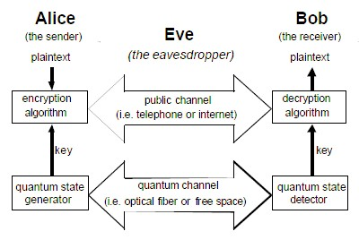
Fig1 A Quantum Cryptographic communication system for securely transferring random key

III-Key Generation

Quantum property of light is used to generate key. Photon has a property called polarization, which is the plane in which the electric field oscillates. Their polarization state can be linear or circular, or it can be elliptical, which is anywhere in between of linear and circular polarization. We can use photons of different polarizations to represent quantum states. Each of these photons is in a state denoted by one of the four following symbols:—, |, /, \ The first two photon states are emitted by a polarizer which is set with a rectilinear orientation and the other two states are emitted by a polarizer which is set with a diagonal orientation.

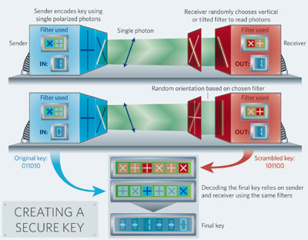

Fig. 2 Creating a secured key using quantum cryptography

In order to communicate, a coding system is necessary. State | codes 1, while— codes 0, and State / codes 0, while \ codes 1[12]. +(0)= —, +(1)= | , x(0)= / , x(1)= \
For example: If Alice wants to transmit the conventional bit 0 or 1, she may choose to use + and consequently send out over the quantum channel —, |, or choose to use x and consequently send out /, \
If Alice is sending only | and— to Bob, the coding system shall identify that Alice is using the base +. For example, if Alice sends sequence of photons: | , | ,— ,— ; the binary number represented with these states is 1100. Now, if Bob wants to obtain a binary number sent by Alice, he needs to receive each photon in the same basis. In this case, this is + basis. A device called a polarizer allows us to place a photon in a particular polarization. The polarization basis is the mapping we decide to use for a particular state.

IV- Securing Key Distribution

The representation of bits through polarized photons is the foundation of quantum cryptography that serves as the underlying principle of quantum key distribution [2,10]. Thus, while the strength of modern digital cryptography is dependent on the computational difficulty of factoring large numbers, quantum cryptography is completely dependent on the rules of physics and is also independent of the processing power of current computing systems. Since the principle of physics will always hold true, quantum cryptography provides an answer to the uncertainty problem that current cryptography suffers from, it is no longer necessary to make assumptions about the computing power of malicious attackers or the development of a theorem to quickly solve the large integer factorization problem. Keys can be distributed using quantum cryptography [6] in the following manner. The sender will send the message to the receiver using a photon gun.
The stream of photons will be in one of the four polarization that corresponds to vertical, horizontal or diagonal in opposite directions (0,45,90.135 degree).At the receiver’s end the receiver will randomly choose a filter and count and measure the correct photon polarization. Now, receiver will communicate with sender (out-of-band) about their correct measurement (without sending actual measurement values).
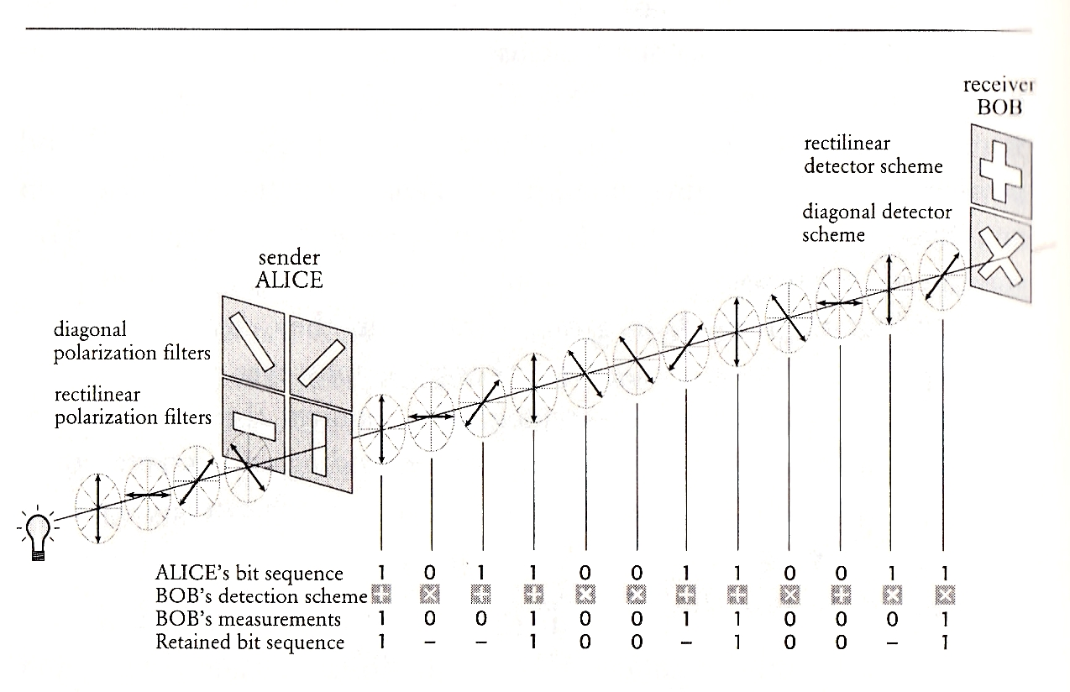

Fig3 Working of Quantum Cryptography

The photons that were incorrectly measured will be discarded and the correctly measured photons will be translated into bits based on their polarization. Now, sender and receiver will generate one time pad combining their results. This one-time pad [14] will be used in one time information exchange between them. None of them can know the actual key in advance because the key is the product of both their random choices. Now, if an attacker tries to eavesdrop, he must select the correct filter otherwise the photon will get destroyed. Even if attacker is able to successfully eavesdrop, the information which he will get will be of little use unless he has the knowledge of correct polarization of each particular photon. As a result attacker will not correctly interpret meaningful keys and thus be thwarted in his endeavors.

1. Secured quantum cryptography algorithm (SQCA)

Because of the limitations of Classical Cryptography, a new algorithm has been proposed in this paper, SQCA (Secured Quantum Cryptography Algorithm). SQCA, have combined effects of quantum computing with the classical cryptography. It results into a fast cryptosystem then can’t be cracked easily. Here, along with classical Cryptography Algorithm (RSA), the fast speed effect of Shor’s algorithm added which results in an efficient, secure and faster algorithm. The complexity of SQCA is O(logN), which is faster and efficient than any classical algorithm(here, RSA). The maximum number of bits that can be supported by this algorithm is also higher as it supports 2N qubits. Random attacks are not possible in SQCA algorithm and for brute force attack, the maximum key size than can be broken in SQCA is quite large i.e. 1024 bits. The maximum key size than SQCA supports is also large i.e. 256. TABLE 1 show
a comparison between Classical cryptography and Quantum Cryptography.

TABLE 1. COMPARISON OF CLASSICAL AND QUANTUM CRYPTOGRAPHY

Property | RSA | SHOR’S | SQCA
Complexity | O(N ^{k}) | O((log N)³ ) | O(logN)
No. of bits | N | 2N | 2N
Key size | 512 | 512 | 1024
Brute Force  Attack | Largest  broken  512 bit  value | Largest  broken  512 bit  value | Largest  broken  1024 bit  value
Random  Attack | 2.2  months | < 1  second | Not  possible

SQCA is developed on the quantum entanglement principle [8] of quantum physics. Quantum Entanglement is a non local property that allows a set of qubits to express higher correlation than is possible in classical systems [8]. The intruder cannot easily crack the data and if he tries for the random attack then it is almost impossible in the case of SQCA. Brute force attack, however, is possible but it also takes years to achieve it and with the increase in the number of qubits, it reaches next to impossible. SQCA results into a more secured quantum key distribution that is difficult to break. Hence, it ensures a more secured data transfer without any intrusion. But it is difficult to implement SQCA algorithm because of the decoherence problem [9] faced by quantum mechanics. Also, the hardware required to implement this algorithm is not available properly.

V-CONCLUSION

Quantum cryptography promises to revolutionize secure communication by providing security based on the fundamental laws of physics, instead of the current state of mathematical algorithms or computing technology. Hence, the resulting Quantum Cryptosystem is more secure and cannot be cracked easily. The devices for implementing such methods exist and the performance of demonstration systems is being continuously improved. Within the next few years, such systems could start encrypting some of the most valuable secrets of government and industry.

REFERENCES
[1] Bennett, C. H.1992, “Quantum cryptography using any two non orthogonal states”, Physical Review Letters, 68, (21), 3121–3124.
[2] Inoue, K. 2006, “Quantum Key Distribution Technologies”, IEEE journal of selected topics in quantum electronics, 12, (4), 888 - 896 .
[3] Homer, Iliad 6.213, transl. Ian Johnston (in English), Malaspina University-College, Nanaimo, BC, Canada (2000).
[4]P. Shor, J. Priskill, “Simple Proof of Security of the BB84 Quantum Key Distribution Protocol”, Physical Review Letters, Vol. 85, pp. 441 - 444, 2000.
[5] Fangxing Xu et al. Chinese Science Bulletin July 2009 vol. 54
[6] Vladimir L. Kurochkin and Igor G.Neizvestny (2009). Quantum Cryptography. 10th INTERNATIONAL CONFERENCE AND SEMINAR EDM'2009, 166-170. doi: 10.1109/EDM.2009.5173960
[7] Nicolas Gisin, Gr´egoire Ribordy, Wolfgang Tittel and Hugo Zbinden." Quantum cryptography" (April 1, 2007; submitted to Reviews of Modern Physics)
[8] Goel, R., Garuba, M., Girma, A. 2007, “Research directions in quantum cryptography”, Information Technology 2007 ITNG '07 Fourth International Conference, 779-784.
[9] Feynman, R.P. Simulating physics with computers // International Journal of Theoretical Physics. — 1982. — V. 21. — Number 6. — P. 467—488 [1]
[10] E.A. Poe, The Gold Bug, in Tales of Mystery and Imagination, Wordsworth Editions Ltd., Ware, pp. 1-46 (1993).
[11] Bennett, C. H., Brassard. G. 1984, “Quantum cryptography: public key distribution and coin tossing”, Proceedings IEEE international
Conference on computers, systems, and signal processing.
[12] Phaneendra, H.D., Shivakumar, M.S., Vidya, R.C. 2006, “Quantum algorithms and hard problems”, 5th IEEE International Conference
on Cognitive Informatics, 2, 783 -787,
[13] Wiesner, S. 1983, “Conjugate Coding”, Sigact News, 15, (1), 78 – 88
[14] Vernam, G.S. 1926, “Cipher printing telegraph systems for secret wire and radio telegraphic communications”, Journal of the IEEE,55, 109 – 115.
[15] C. Elliott, D. Pearson, and G. Troxel, "Quantum cryptography in practice," Karlsruhe, Germany: Proceedings of the 2003 conference on Applications, technologies, architectures, and protocols for computer
communications 2003.

